KHWOPA SECONDARY SCHOOL
DEPARTMENT OF COMPUTER SCIENCE
Dekocha-06, Bhaktapur

A FINAL REPORT
ON
“STUDENT MEAL PLANNER”

A requirement for the partial fulfillment of grade 12 NEB Examination
Title: Student Meal Planner

Submitted by:
Samriddhi Baiju (435)
Sara Karmacharya (437)
Anuska Basnet (458)
Shrena Prajapati (538)
Submitted to:
Khwopa Secondary School
Department of Chemistry
Dekocha-6,Bhaktapur

Submission date: 2082/0 /

DEPARTMENT OF COMPUTER SCIENCE
KHWOPA SECONDARY SCHOOL
Dekocha-06, Bhaktapur

CERTIFICATE
This is to certify that the project entitled “Student Meal Planner” submitted by Miss Samriddhi Baiju, Miss Sara Karmacharya, Miss Anuska Basnet, and Miss Shrena Prajapati, in partial fulfillment of the requirements for internal assessment of Computer Science of NEB (Nepal Education Board), Class 12 (XII), is a bona fide work carried out under our supervision. To the best of our knowledge, this work has not been submitted previously for any examination and may be placed before the examination board for evaluation.
Panel of Examiners:
Project Supervisor

………………………….
External Examiners

………………………….
Signature
Date
Name

ACKNOWLEDGEMENT
We would like to express our sincere gratitude to all those who have directly or indirectly supported us in the completion of this project. First and foremost, we are thankful to the Department of Computer Science of Khwopa Secondary School for providing us with the opportunity to carry out the project entitled “Student Meal Planner” We would also like to thank our computer teachers ………………. for their continuous guidance, encouragement, and valuable suggestions throughout the project development. Their support motivated us to successfully complete this challenging task. We are equally grateful to our friends who helped us during the project by providing useful references, coding resources, and assistance in preparing the project report.

ABSTRACT
This project is developed using HTML, CSS, and JavaScript. It is a Student Meal Planner designed to help students select suitable meal options based on their budget and food preferences. The system allows users to enter their available budget and preferred food choices, after which it suggests a meal that can be prepared within the given criteria.
The main objective of this project is to demonstrate the practical use of front-end web development technologies in solving a real-life problem faced by students. HTML is used to create the structure of the web application, CSS is used to enhance its visual design, and JavaScript is used to process user input and generate appropriate meal suggestions.
Through this project, we gained practical knowledge of integrating user input with logical conditions and dynamic output. The project highlights how web technologies can be used to create simple, efficient, and user-friendly applications that assist students in making affordable meal choices.

TABLE OF CONTENTS
CONTENTS
ACKNOWLEDGEMENT 3
ABSTRACT 4
INTRODUCTION 6
BACKGROUND 6
OBJECTIVES 6
APPLICATIONS 6
SCOPE AND LIMITATIONS 7
SCOPE 7
LIMITATIONS 7
METHODOLOGY 8
TOOLS AND PLATFORMS 10
DISCUSSION AND CONCLUSION 11
APPENDIX 12
APPENDIX-2 13
APPENDIX-3 14
APPENDIX-4 15
APPENDIX-5 16
APPENDIX-6 17
REFERENCES 18

INTRODUCTION

BACKGROUND
Technology is rapidly advancing in today’s world, and the internet has become an essential part of everyday life. With the increasing use of web-based applications, people now rely on online systems for planning, decision-making, and managing daily activities. Students, in particular, face challenges related to time management, budgeting, and maintaining proper eating habits.
Web development has grown significantly with the use of technologies such as HTML, CSS, and JavaScript. These technologies allow developers to create interactive and user-friendly applications that solve real-life problems. By using front-end web technologies, simple yet effective systems can be developed to assist users in making informed decisions.
In this project, we have developed a Student Meal Planner using HTML, CSS, and JavaScript. The system helps students select a suitable meal by taking their budget and food preferences as input and suggesting a meal that can be prepared within those constraints. This project demonstrates the practical use of web development concepts learned in the classroom.

OBJECTIVES
- To understand the practical use of HTML, CSS, and JavaScript in web development
- To design a simple and interactive web-based application
- To process user input and display appropriate output using JavaScript
- To help students make affordable meal choices based on budget and preferences

APPLICATIONS
- To assist students in selecting meals within a limited budget
- To demonstrate the practical use of front-end web technologies
- To promote basic planning and decision-making skills using technology
- To show how web applications can solve real life problems in a simple way

SCOPE AND LIMITATIONS

SCOPE
This project is limited to a front-end web-based application developed using HTML, CSS, JavaScript. It demonstrates the practical use of web development technologies such as HTML, CSS, JavaScript. This project aims to help students understand how simple web applications can be developed to solve real life problems like meal planning. It also helps students gain basic knowledge of front-end programming and logical implementation.

LIMITATIONS
The limitations of this project are that it is a simple front-end application and does not use advanced technologies such as databases or backend programming. The meal suggestions are limited to predefined data, and the application requires access tona web browser to function properly.

METHODOLOGY
The student meal planner is designed using HTML, CSS, and JavaScript, leveraging functions, objects, and DOM manipulation to create an interactive application.
- On the basis of functions used in the program
I. Function Prototypes and Definitions
  - The program defines several JavaScript functions like planMeal() and getrandomMeal(type, preference, budget) to handle the logic.
  - Function definitions include the function name, input parameters, and the body containing the instructions and return values.

II. Function Calls
  - Functions are called in response to user actions, such as clicking the “Generate Meal Plan” button, which triggers planMeal().

II. Function Logic
  - getRandomMeal() filters meal options based on user preferences (veg/non-veg), meal type (breakfast, lunch, snacks, dinner), and budget.
  - A random meal is selected from the filtered list and displayed dynamically using DOM manipulation.

- On the basis of data structure used in the program
  - JavaScript objects and arrays are used to store the meal data.
  - Each meal is represented as an object with properties: id, name, ingredients, cost, type, and calories.
  - Arrays of meal objects allow easy access and filtering of meals based on type, preference, and budget.

- On the basis of DOM and eventhaldling used in the program
  - document.getElementById() is used to access input fields and the result container.
  - innerHTML is used to dynamically display the generated meal plan.
  - Event listeners (via the onclick attribute) trigger the functions when the user interacts with the interface.
- Other programming constructs used in the program
  - Conditional statements (if, else if, else) to filter meals based on user input and check budget constraints.
  - Random selection using Math.random() and Math.floor() to choose a meal from available options.
  - Assignment operators (=, <=) and comparison operators (===, >, <) for logical checks.

TOOLS AND PLATFORMS
The student meal planner project is developed using HTML, CSS, and JavaScript, which are standard web technologies for building interactive web applications.
HTML is used to create the structure of the webpage, including input fields, dropdowns, buttons, and display areas.
CSS is used for styling the page, adding colors, fonts, layouts, and hover effects to make the interface visually appealing.
JavaScript is used to add interactivity, including filtering meals, selecting randomly, checking the budget, and dynamically updating the webpage using DOM manipulation.

DISCUSSION AND CONCLUSION

I.DISCUSSION
By doing the student meal planner project, we are able to create an interactive web application that helps users plan meals based on budget, preference, and meal type. In this project, we learned how to use JavaScript functions, objects, arrays, and DOM manipulation to filter data, randomly select meals, and display results dynamically on the webpage. The project also demonstrates how HTML and CSS can be used to build a user-friendly interface with clear input options and visual feedback.

II.CONCLUSION
In conclusion, the student meal planner project provides a simple yet functional platform for students to plan affordable meals. With a clean and interactive interface, the application offers easy navigation, dynamic feedback, and real-time budget checking. Despite its simplicity, the project demonstrates key programming concepts and serves as a practical introduction to web development, combining the front-end design and JavaScript logic effectively.

APPENDIX
This is the starting interface of the program after running it in a browser.
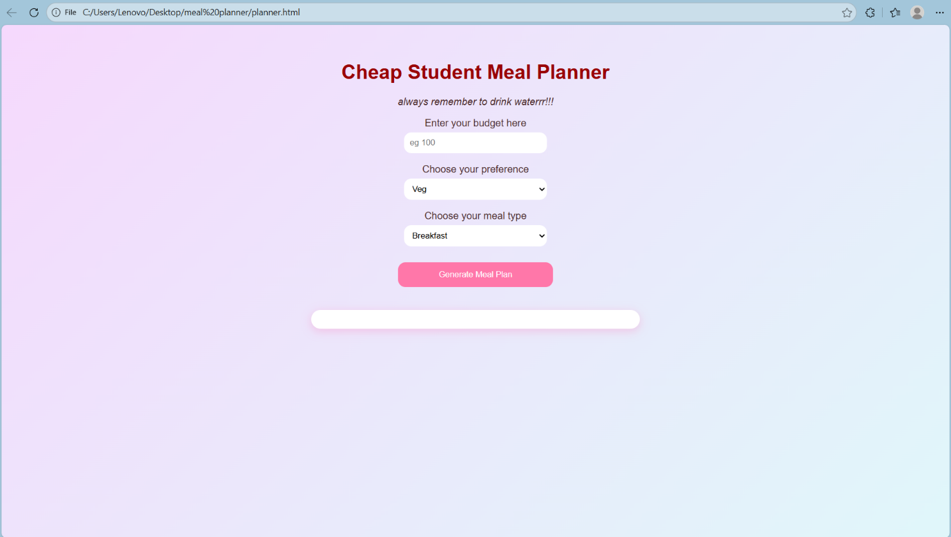
After the user inputs the required fields, the programs shows the result as below:
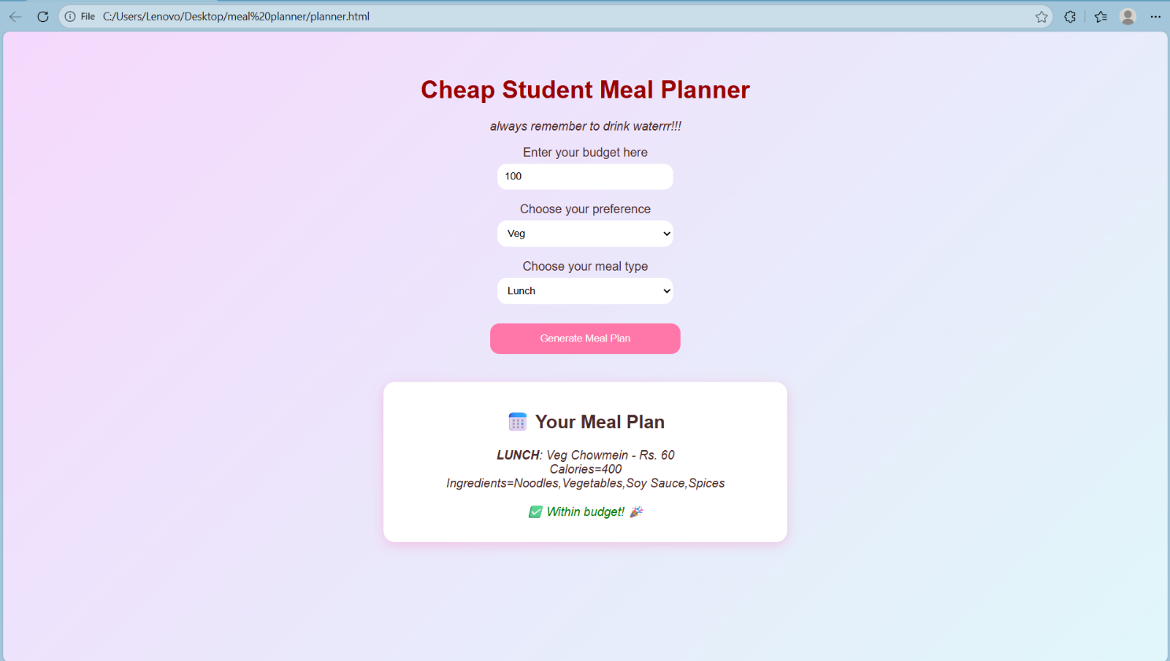

APPENDIX-2
This is the output when there are no options in a certain budget range or preference
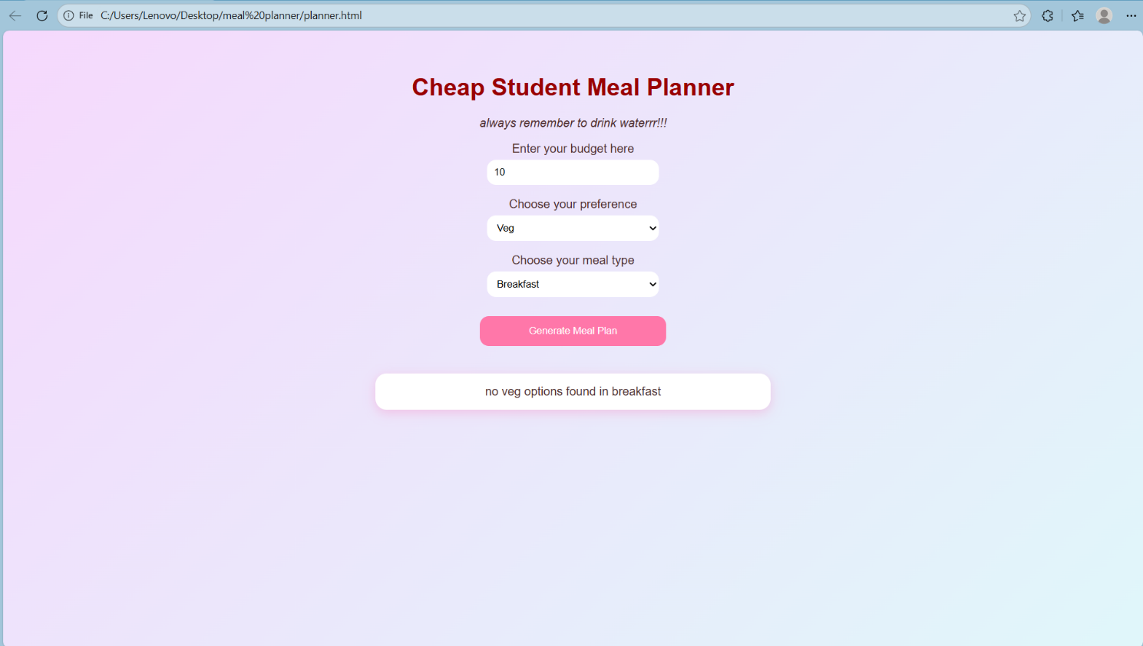

APPENDIX-3
This is the code we used to develop the planner.
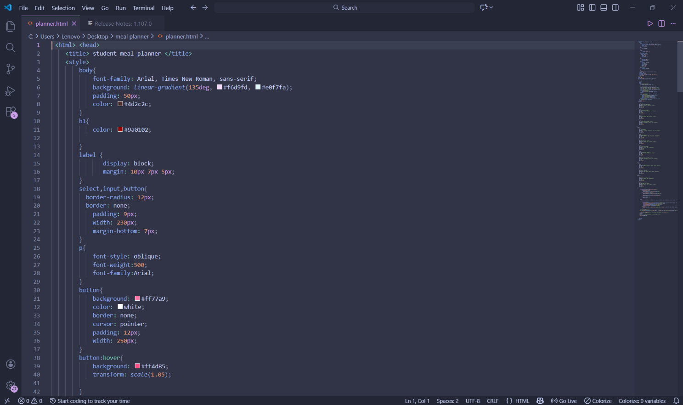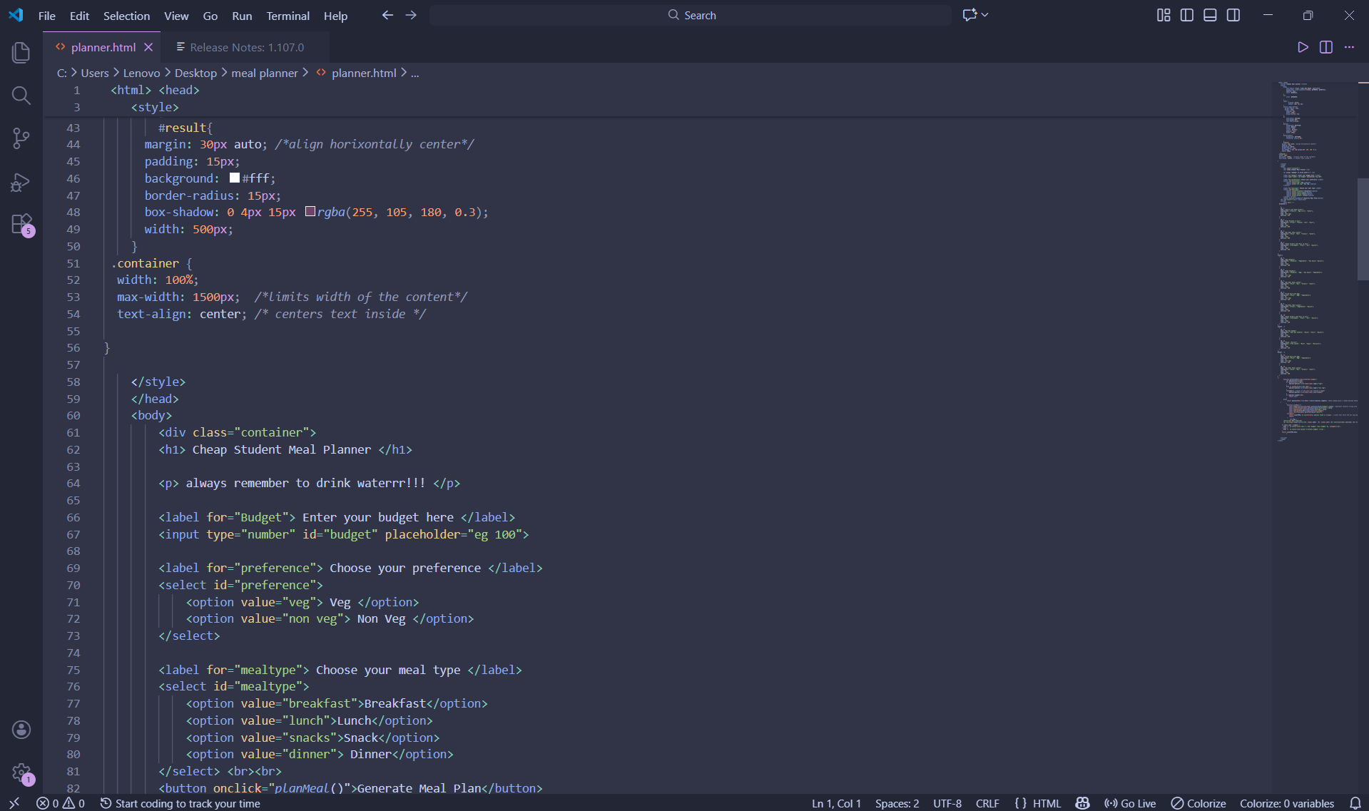

APPENDIX-4
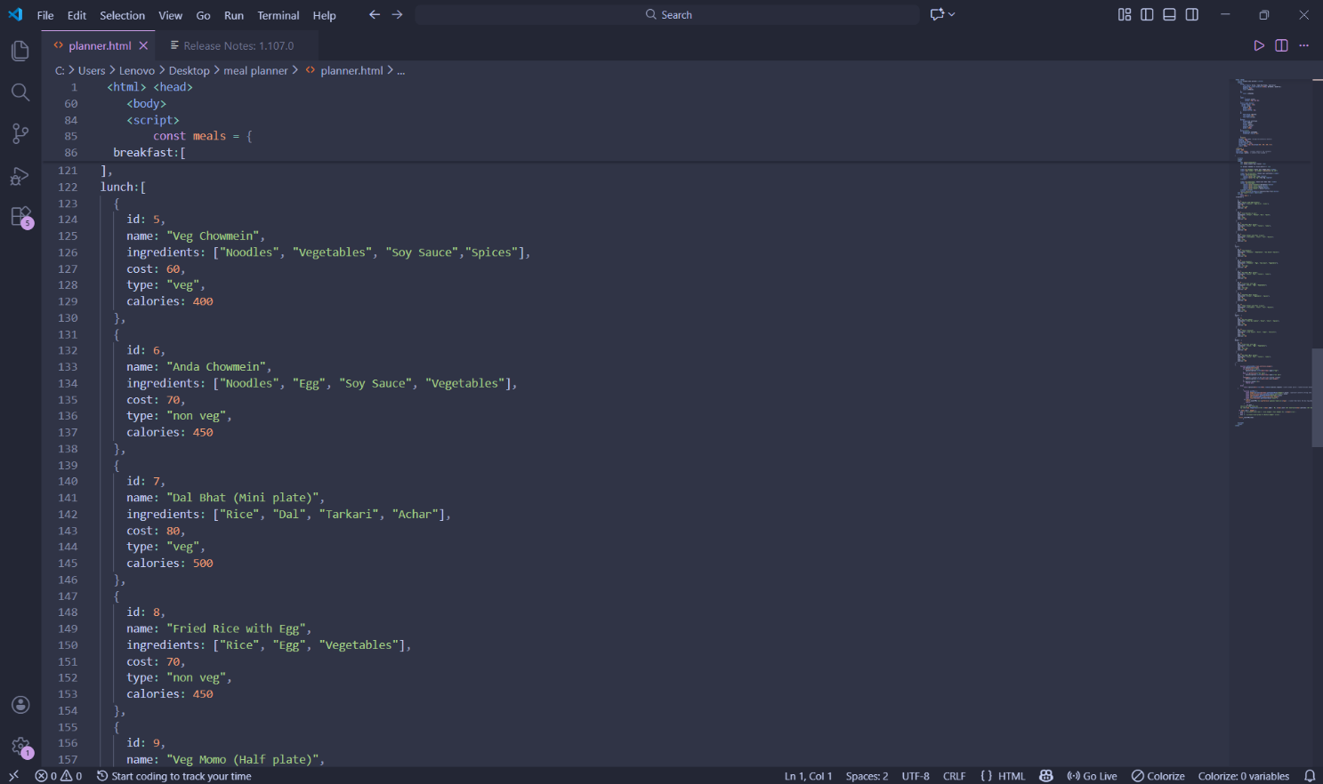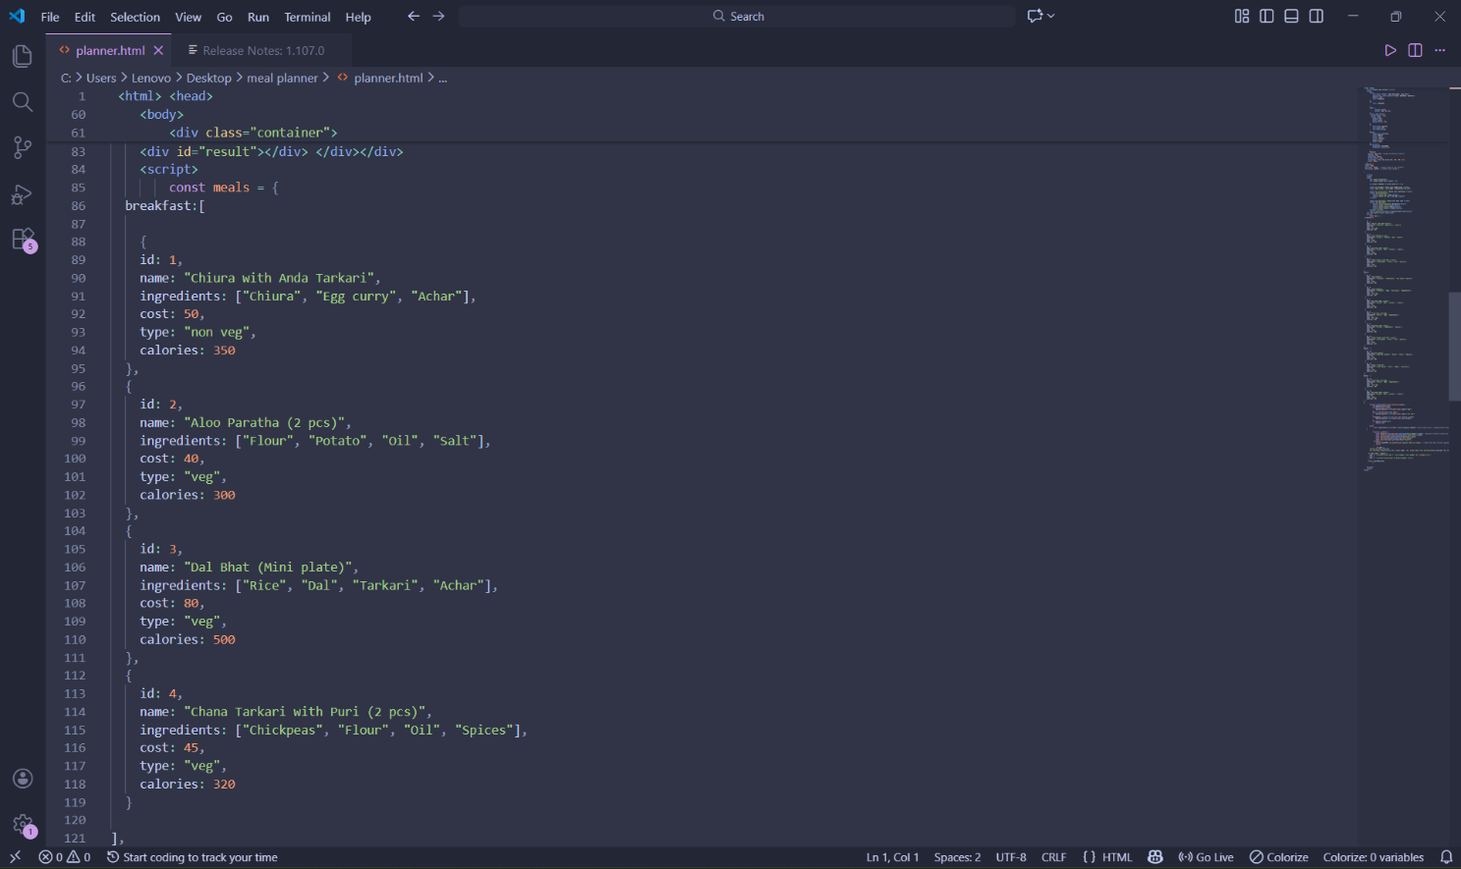

APPENDIX-5
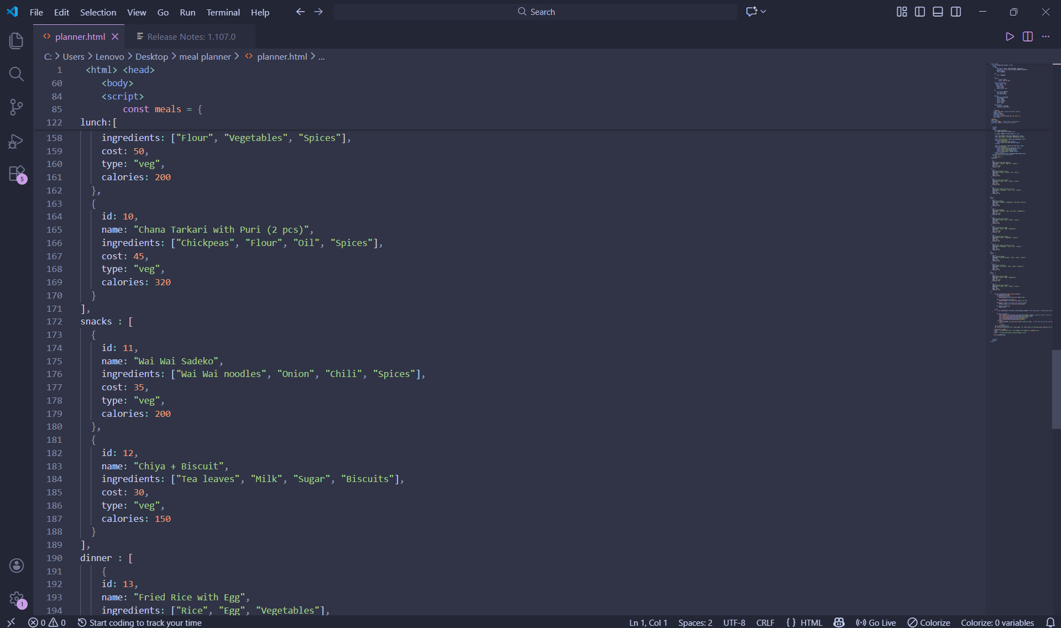
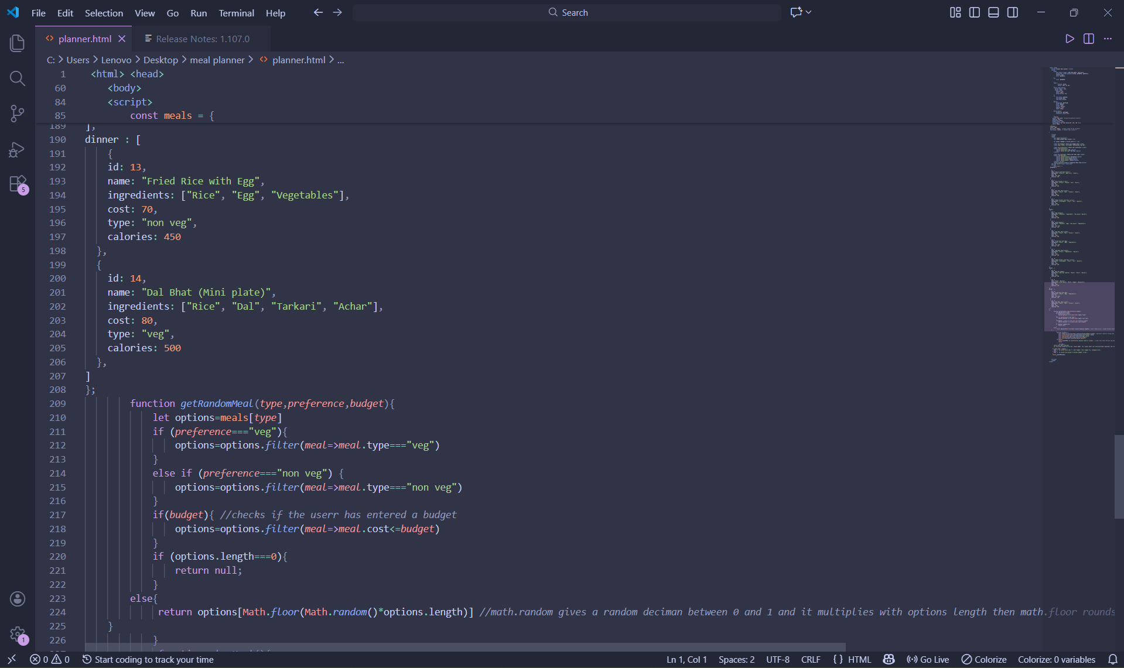

APPENDIX-6
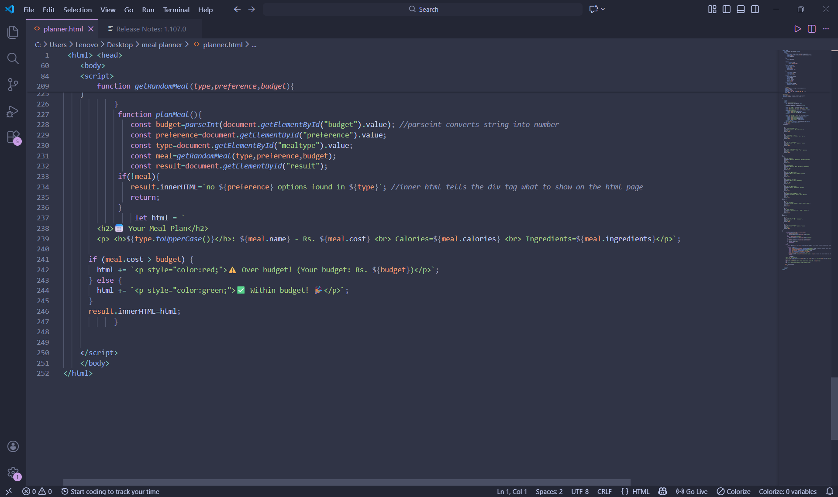

REFERENCES
- W3Schools. JavaScript Math.random() and Array Filter Methods.
https://www.w3schools.com/js/js_array_methods.asp
- GeeksforGeeks. How to use manipulate DOM elements in JavaScript
https://www.geeksforgeeks.org/javascript/how-to-manipulate-dom-elements-in-javascript/
- YouTube tutorials: Vanilla JavaScript Course by Traversy Media, 2025
- Heritage Publications. A Textbook of Computer Science, Grade XII, 2025 Revised edition

